EE223 Homework 3

Designed of a Beta Multiplier

Enrique Hernandez Sanchez

10/13/18

1. Run a Dc simulation with VDD = 1V, Temperature = 27c in Typical Corner.

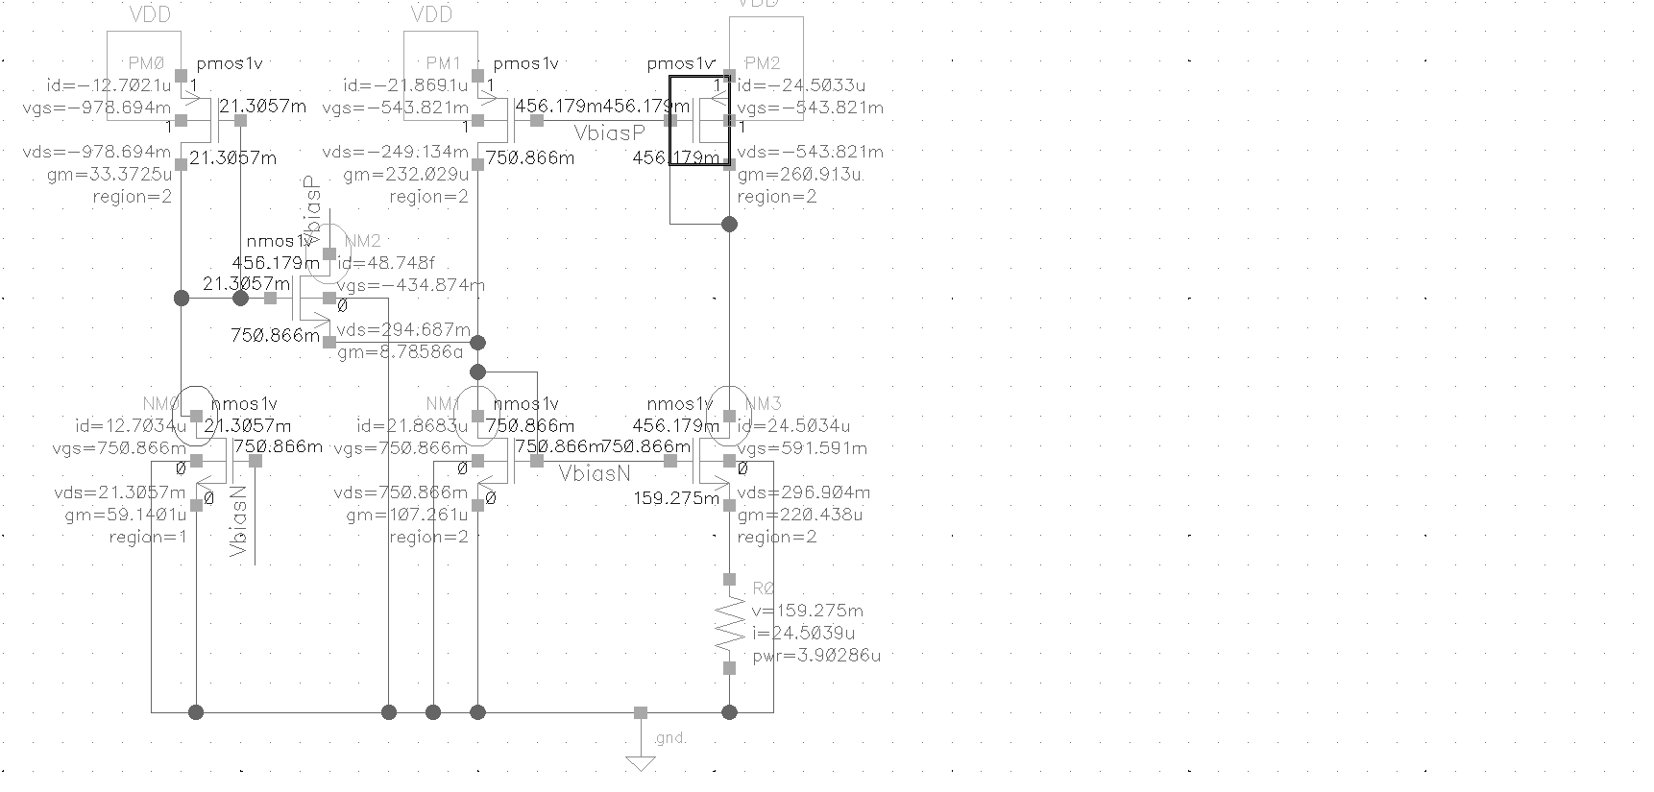

Figure 1: Operating Point information and node voltages

1. ADE-XL transient simulation for 1u

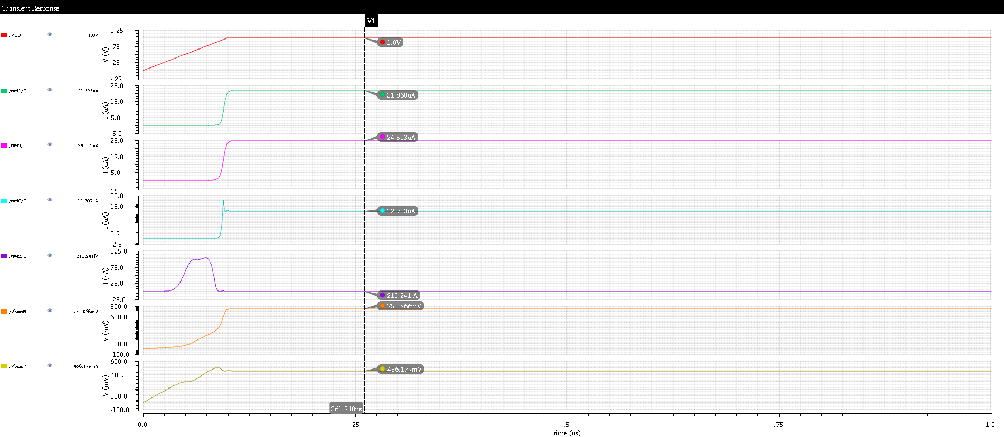

Figure 2: Transient waveforms with startup circuit. (VDD= red trace, Vbiasn =orange trace, Vbiasp=yellow trace, NM1 =green trace, NM3=violate trace, NMo=blue trance, NM2=purple trance)

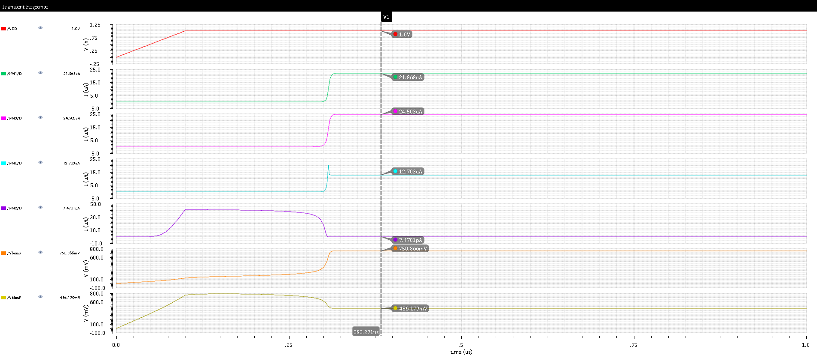

Figure 3: Transient waveforms with startup circuit. (VDD= red trace, Vbiasn =orange trace, Vbiasp=yellow trace, NM1 =green trace, NM3=violate trace, NMo=blue trance, NM2=purple trance)

1. From simulation find Kp value

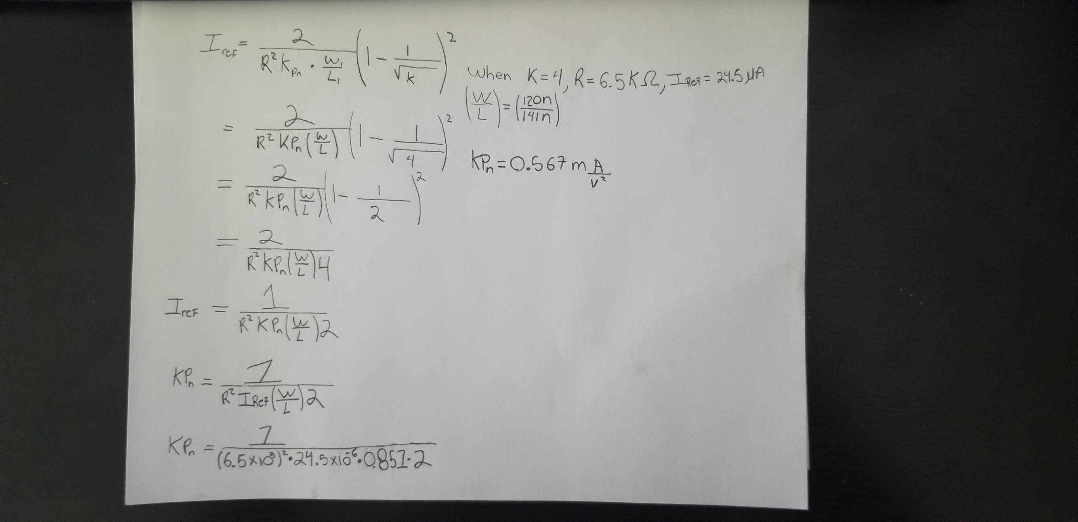

Figure 4: Kp value using simulation Iref

1. Using ADL-XL, simulate the circuit in the fallowing conditions and check if the circuit starts without problem. Measure the current through M4 at 1us and Plot it over the fallowing PVT corners.
   1. Process variation:

|  |  |  |  |  |  |  |  |
| --- | --- | --- | --- | --- | --- | --- | --- |
| Parameter | Min | Max | C5_0 | C5_1 | C5_2 | C5_3 | C5_4 |
| VDD |  |  | 1 | 1 | 1 | 1 | 1 |
| gpdk045.scs |  |  | ff | fs | sf | ss | tt |
| temperature |  |  | 27 | 27 | 27 | 27 | 27 |
| value(IT("/NM3/S") 1e-06) | -2.54E-05 | -2.35E-05 | -2.54E-05 | -2.44E-05 | -2.46E-05 | -2.35E-05 | -2.45E-05 |

* 1. Supply variation:

|  |  |  |  |  |  |  |  |
| --- | --- | --- | --- | --- | --- | --- | --- |
| Parameter |  |  | C6_0 | C6_1 | C6_2 | C6_3 | C6_4 |
| VDD |  |  | 8.00E-01 | 9.00E-01 | 1 | 1.1 | 1.2 |
| gpdk045.scs |  |  | tt | tt | tt | tt | tt |
| temperature |  |  | 27 | 27 | 27 | 27 | 27 |
| Output | Min | Max | C6_0 | C6_1 | C6_2 | C6_3 | C6_4 |
| value(IT("/NM3/S") 1e-06) | -2.96E-05 | -1.66E-05 | -1.66E-05 | -2.10E-05 | -2.45E-05 | -2.73E-05 | -2.96E-05 |

* 1. Temperature Variation:

|  |  |  |  |  |  |  |  |
| --- | --- | --- | --- | --- | --- | --- | --- |
| Parameter | Min | Max | C7_0 | C7_1 | C7_2 | C7_3 | C7_4 |
| VDD |  |  | 1 | 1 | 1 | 1 | 1 |
| gpdk045.scs |  |  | tt | tt | tt | tt | tt |
| temperature |  |  | -40 | 0 | 25 | 50 | 100 |
| value(IT("/NM3/S") 1e-06) | -2.73E-05 | -1.85E-05 | -1.85E-05 | -2.22E-05 | -2.44E-05 | -2.60E-05 | -2.73E-05 |

* 1. All PVT variations:

|  |  |  |  |  |  |  |  |  |
| --- | --- | --- | --- | --- | --- | --- | --- | --- |
| Parameter | Min | Max | C9_0 | C9_1 | C9_2 | C9_3 | C9_4 | C9_5 |
| VDD |  |  | 9.00E-01 | 9.00E-01 | 9.00E-01 | 9.00E-01 | 1 | 1 |
| gpdk045.scs |  |  | ff | ff | ff | ff | ff | ff |
| temperature |  |  | -40 | 0 | 50 | 100 | -40 | 0 |
| value(IT("/PM2/D") 1e-06) | -3.39E-05 | -1.55E-05 | -1.73E-05 | -2.06E-05 | -2.35E-05 | -2.43E-05 | -1.92E-05 | -2.30E-05 |
| C9_6 | C9_7 | C9_8 | C9_9 | C9_10 | C9_11 | C9_12 | C9_13 | C9_14 |
| 1 | 1 | 1.1 | 1.1 | 1.1 | 1.1 | 9.00E-01 | 9.00E-01 | 9.00E-01 |
| ff | ff | ff | ff | ff | ff | fs | fs | fs |
| 50 | 100 | -40 | 0 | 50 | 100 | -40 | 0 | 50 |
| -2.72E-05 | -2.93E-05 | -2.10E-05 | -2.51E-05 | -3.02E-05 | -3.39E-05 | -1.64E-05 | -1.95E-05 | -2.18E-05 |
| C9_15 | C9_16 | C9_17 | C9_18 | C9_19 | C9_20 | C9_21 | C9_22 | C9_23 |
| 9.00E-01 | 1 | 1 | 1 | 1 | 1.1 | 1.1 | 1.1 | 1.1 |
| fs | fs | fs | fs | fs | fs | fs | fs | fs |
| 100 | -40 | 0 | 50 | 100 | -40 | 0 | 50 | 100 |
| -2.20E-05 | -1.84E-05 | -2.21E-05 | -2.59E-05 | -2.73E-05 | -2.01E-05 | -2.42E-05 | -2.92E-05 | -3.22E-05 |
| C9_24 | C9_25 | C9_26 | C9_27 | C9_28 | C9_29 | C9_30 | C9_31 | C9_32 |
| 9.00E-01 | 9.00E-01 | 9.00E-01 | 9.00E-01 | 1 | 1 | 1 | 1 | 1.1 |
| sf | sf | sf | sf | sf | sf | sf | sf | sf |
| -40 | 0 | 50 | 100 | -40 | 0 | 50 | 100 | -40 |
| -1.64E-05 | -1.94E-05 | -2.15E-05 | -2.19E-05 | -1.86E-05 | -2.24E-05 | -2.59E-05 | -2.71E-05 | -2.05E-05 |
| C9_33 | C9_34 | C9_35 | C9_36 | C9_37 | C9_38 | C9_39 | C9_40 | C9_41 |
| 1.1 | 1.1 | 1.1 | 9.00E-01 | 9.00E-01 | 9.00E-01 | 9.00E-01 | 1 | 1 |
| sf | sf | sf | ss | ss | ss | ss | ss | ss |
| 0 | 50 | 100 | -40 | 0 | 50 | 100 | -40 | 0 |
| -2.48E-05 | -2.97E-05 | -3.22E-05 | -1.55E-05 | -1.83E-05 | -1.98E-05 | -1.98E-05 | -1.78E-05 | -2.15E-05 |
| C9_42 | C9_43 | C9_44 | C9_45 | C9_46 | C9_47 | C9_48 | C9_49 | C9_50 |
| 1 | 1 | 1.1 | 1.1 | 1.1 | 1.1 | 9.00E-01 | 9.00E-01 | 9.00E-01 |
| ss | ss | ss | ss | ss | ss | tt | tt | tt |
| 50 | 100 | -40 | 0 | 50 | 100 | -40 | 0 | 50 |
| -2.45E-05 | -2.51E-05 | -1.98E-05 | -2.41E-05 | -2.86E-05 | -3.03E-05 | -1.64E-05 | -1.95E-05 | -2.17E-05 |
| C9_51 | C9_52 | C9_53 | C9_54 | C9_55 | C9_56 | C9_57 | C9_58 | C9_59 |
| 9.00E-01 | 1 | 1 | 1 | 1 | 1.1 | 1.1 | 1.1 | 1.1 |
| tt | tt | tt | tt | tt | tt | tt | tt | tt |
| 100 | -40 | 0 | 50 | 100 | -40 | 0 | 50 | 100 |
| -2.21E-05 | -1.84E-05 | -2.22E-05 | -2.60E-05 | -2.73E-05 | -2.03E-05 | -2.45E-05 | -2.94E-05 | -3.23E-05 |

|  |  |  |  |  |
| --- | --- | --- | --- | --- |
| Mean | sum of squares | sum of squares /(n-1) | Mean + sigma | Mean - sigma |
| -2.33168E-05 | 1.24249E-09 | 4.58902E-06 | -1.87278E-05 | -2.79059E-05 |

* 1. Plot Gm vs Temp of Mn1

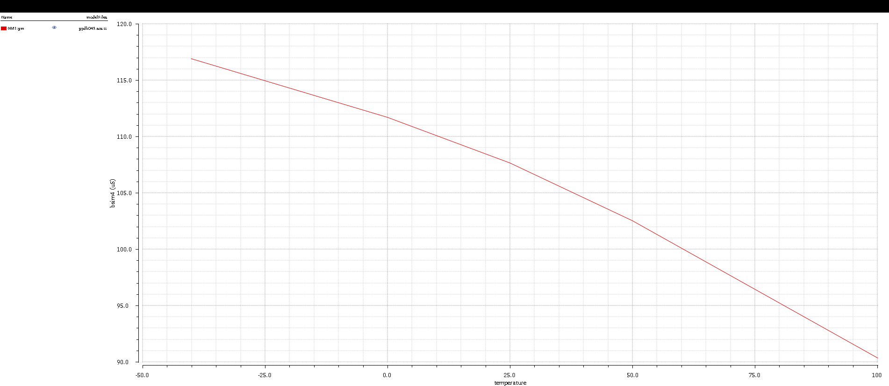

Figure 5: NM1 Gm vs Temp